Dana’s Discovery Kids Preschool
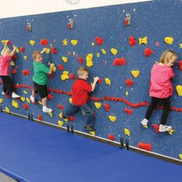
School Schedule

8am- Early drop-off (free play in the gym)

8:40am- All school story time
9:15am- Children excused to classes
9-9:45am- Structured curriculum in classrooms
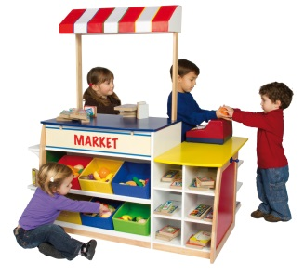
9:45-11am- Free center choice time

11am- All school clean up
11:15-30am- Snack
11:30-11:55am- Closing circle

